Minal Village Hall

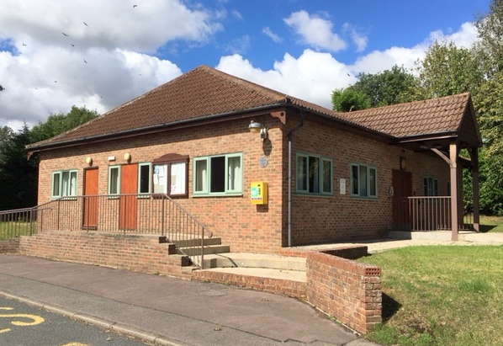
Built in 1986, Minal Village Hall is an ideal venue for wedding receptions, buffets, children's parties, barn dances, adult education classes and many other functions. The main entrance is approached by a shallow inclined ramp, and adjacent to the hall is a car park for approximately 12 cars
The hall which measures 7m x 14m provides free wi-fi, remote controlled heating and Grade-A double glazing for sound suppression. The hall comfortably accommodates 150 people standing and 60 people sitting, although the hall is licensed for 200 standing and 100 sitting. There are folding trestle tables and smaller tables and chairs to provide the seating for 100. Crockery and cutlery is available in blue and white china with sufficient place settings for 100. Food can be prepared and served from the kitchen, which is well equipped with hot water, electric cooker, refrigerator, microwave and urn. There is a toilet for wheelchair users.
Post Code for the Village Hall - SN8 2LR

Rates for Social Activities

Village Rates Non-Village Rates

Week – during daytime £6.00/hr £7.50/hr
Weekday – evening £8.00/hr £10.50/hr
Sat/Sun – daytime & evening £8.00/hr £10.50/hr
Sat/Sun – 11pm to midnight £16.00/hr £20.00/hr
Whole day – 0800-2300hrs £65 £95

Commercial Rates - by negotiation with the Committee

Bookings

To place a booking or enquire about availability please contact:-

Lisa Coomber

Tel: 01672 511623

Mob: 07539 031505

or book on line:

http://v2.hallmaster.co.uk/Scheduler/View/6651

