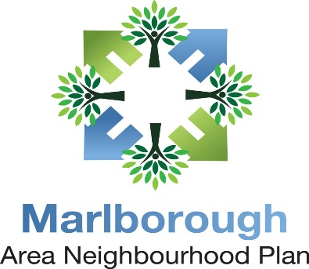
Regulation 14
Consultation Feedback Form

DRAFT NEIGHBOURHOOD PLAN - WE NEED YOUR VIEWS

The Marlborough Area Neighbourhood Plan Steering Group has prepared a Neighbourhood Plan for the period to 2036 (the Plan) for Marlborough, Manton, Mildenhall, and Savernake with the help of the local community.
The Plan sets out a vision for the future of these parish areas with planning policies which will be used to determine local planning proposals. The Steering Group is now inviting comments on the proposals in a Pre-Submission draft of the Plan before it is submitted to Wiltshire Council for formal consideration and wider consultation.
This consultation will be open for 7 weeks from 18 January – 8 March 2021.
This comments sheet, the draft Plan and supporting documents can be viewed and downloaded at:
www.marlborough-tc.gov.uk

You can send your comments via this form or by email to:

enquiries@marlborough-tc.gov.uk

If you need a hard copy of the Plan or would like to comment by letter or need more information, please contact the Town Council at: Marlborough Area Neighbourhood Plan (MANP), c/o Marlborough Town Council, Council Offices, 5 High Street, Marlborough, Wiltshire, SN8 1AA or via email at: enquiries@marlborough-tc.gov.uk
or by telephone at 01672 512487 or 07593 584099

If you are completing this on a computer, you can add as many lines as you need to suit your comments. If you are writing on a printed copy, feel free to add additional sheets.

All comments must be received by midnight on 8 March 2021
Whether replying by email or via this form, your personal details will not be published or shared with anyone. However, if you prefer to comment without identifying yourself you can but your comments will not be taken into account unless your postcode (if you are an individual) or organisation name (if you are not an individual) are included. Please make clear which policy and or page number you are commenting on.

Name:

Post code: (Required)

Address:

Are you responding as an
Organisation or Body | Yes / No
If Yes - Name of organisation or body?

Individual | Yes / No

Consultee Type - capacity in which you are commenting on the Plan - Please answer this even if you do not wish to be identified.
Resident of Marlborough, Manton, Mildenhall or Savernake | Yes / No (please delete as appropriate)
Neighbouring community resident | Yes / No (please delete as appropriate)
Local Business | Yes / No (please delete as appropriate)
Local Voluntary, Community or Faith Group | Yes / No (please delete as appropriate)
Other (please specify) | Yes / No (please delete as appropriate)

PLEASE NOTE: Your personal details will not be published as part of the consultation response, but anonymous comments will not be actioned so please provide contact details to accompany your comments. Communication regarding progress of the Plan and amendments to be made will be publicised. No individual responses will be given. Both Marlborough Town Council (as the qualifying body for the Plan) and the Marlborough Area Neighbourhood Plan Steering Group have a duty to protect personal information and will process personal data in accordance the General Data Protection Regulation (GDPR). The personal data you provide on this form will only be used for the purpose of the Marlborough Area Neighbourhood Plan. The data will be stored on computer and/or manual files. This data will be passed on to Wiltshire Council for the Regulation 16 Consultation.

FEEDBACK/COMMENTS

Plan Page/ Policy Number | COMMENTS/FEEDBACK

