St John the Baptist Church, Minal
invites you to a
Harvest Barn Dance

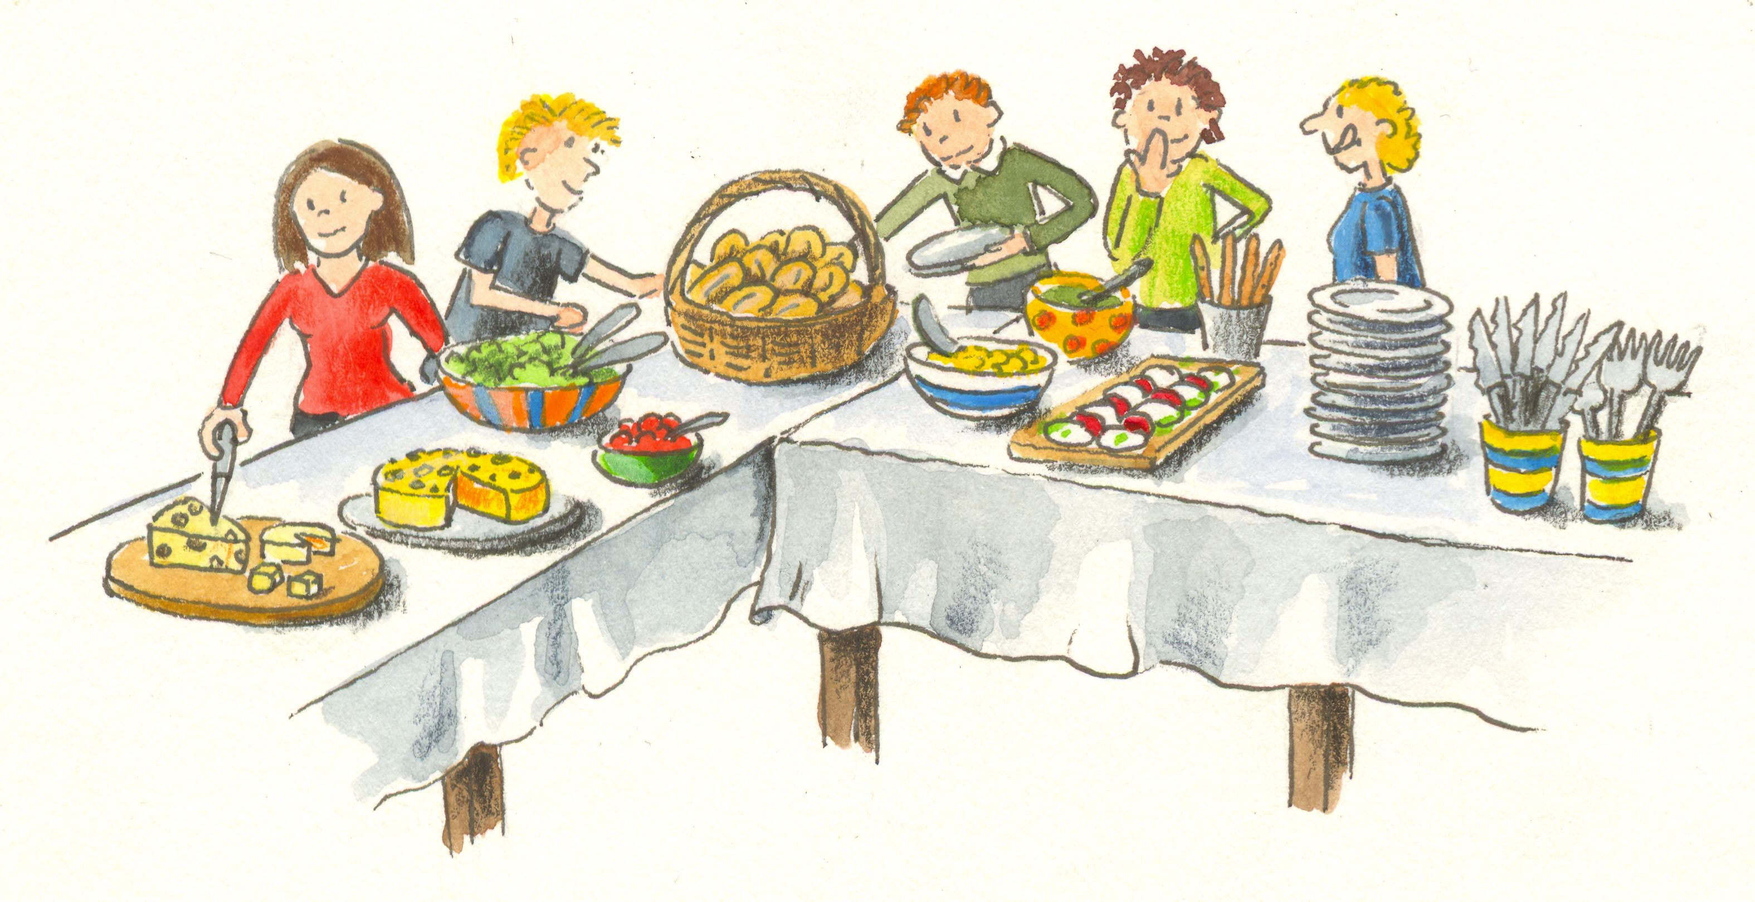
Bring and Share Supper
On Friday 30th September 2022
6.00pm – 8.00pm
In Mildenhall Village Hall

Adults £7.50 Under 13’s free
(including a drink)

Tickets from Gilly Price 07785 568513

